# CS 340 README Template

## About the Project/Project Title

This project uses the CRUD method, through python, which is create, read, update, and delete. When creating the python project, the CRUD method will refer to the CSV file that contains over 10,000 entries of information about specific animals.

## Motivation

The purpose of this project is ultimately to help Grazioso Salvare to create a way to find the best dogs for search-and-rescue training. Different shelters have offered to provide a lengthy and detailed list of all of the dogs, which add up to over ten thousand. By using the create, read, update, and delete methods, the team can find the easiest ways to picks the best dogs for the job, according to their statistics. The files should also be open source so other organizations can use it.

## Getting Started

This project can be completed by anyone, as the resources are included online for free. To start you will need:

1. MongoDB- This can be downloaded online through Mongodb.com. There are also tutorials on how to access files in the terminal.
2. When using MongoDB, you will need access the file (aac_shelter_outcomes.csv) and make a username/password associated with it.
3. When making the Python file to create, read, update, and delete entries, both the database and the Python file must be linked to the interactive Python notebook.
4. “Create” was made by verifying that a new file can be made. It contains a link between the database and if the command returns true or false.
5. Read was made by verifying that the files can be read, according to the user’s preferences. There should be a link between the notebook and the database.
6. The interactive Python notebook must verify that entries are identifiable and can be changed in the database.
7. Make sure the final file is public so more people can use it.

## Installation

The tools needed will be MongoDB, a Python execution program, and an interactive Python notebook. MongoDB can be accessed through a terminal to make necessary changes, while Python programs will be made with the current versions of Spyder and Jupyter Notebook.

## Usage

The CRUD Python module is used to control how the file is used. We could take the spread sheet and manually look up items, or we can use the CRUD method which helps when dealing with a large amount of files. Create, read, update, and delete all play a major role in the development of an ongoing file. The purpose of the project is to easily find certain dogs that can be trained for rescue. Jupyter Notebook allows the team to test the code, use the code, and make sure that the code works as it was intended.

The module should be used to find dogs within a specific criterion. For example, Grazioso Salvara wants to find dogs under two years old and also specific to their breed. This can easily be searched using the read method to find exactly what someone is looking for. The create, update, and delete methods can be set to administrators only, so users don’t accidently add or delete certain data.

### Code Example

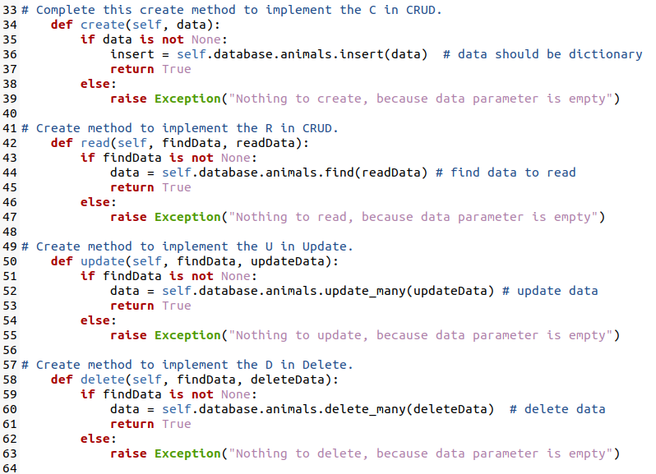

From Jupyter Notebook



This imports the Mongo database.

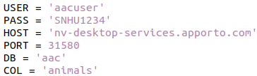

Verification from the Mongo database.

### Tests

Currently, I was unable to connect properly to the database, from Jupyter notebook.



This calls the Python file to the interactive notebook.

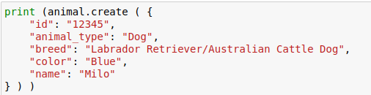

This shows an example of how to test the if the create method works.



This checks for a file and shows it.



This updates a file to something different.



This deletes a certain file.

Screenshots

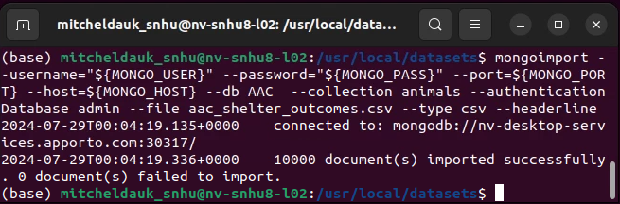

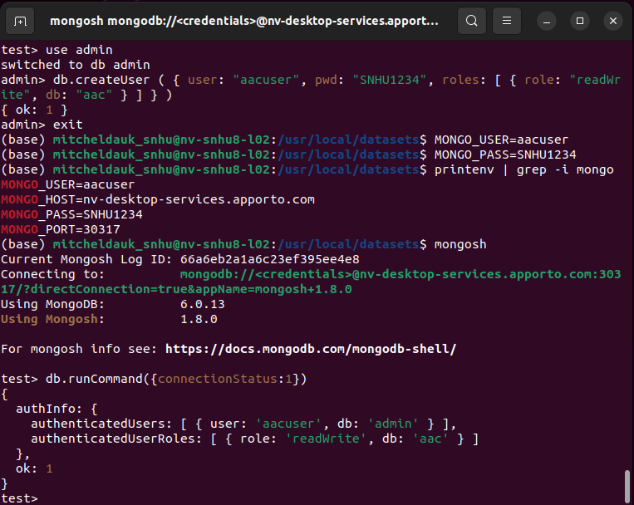

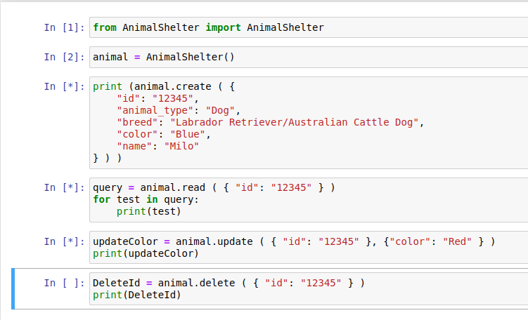

## Required Functionality

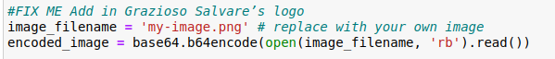

Image of Grazioso’s logo

Showing name in dashboard

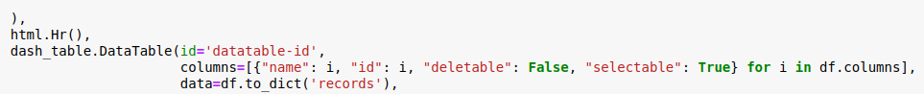

Interactive filtering

Interactive data table

Interactive data table with MongoDB queries

Pie chart

Dashboard

Error loading table and charts

## Tools

MongoDB was used as the model component of the development because of how well it layers. MongoDB works as the Base Level. This includes authentication and indexing for optimized queries. CRUD allows the files to be altered by creating new content, reading content, updating content, and deleting content. MongoDB works well with Python because of its flexible form and the way it collides with the language. Python takes the data in MongoDB and allows anyone to use it how they want.

With Grazioso Salvare, the data is allowed to be manipulated by the user to find out specific information. Any data can be manipulated by the way it is portrayed or how it looks. Grazioso Salvare can now use the information from animals across the globe to find the best ones, without searching through thousands of databases.

## Steps to Complete Project

The project was not easy, and it took many steps, layered into three main levels. First MongoDB allowed me to alter the file and create admin restrictions. Crud was then tested, through Python, to make sure the file could be altered through code, rather than a terminal. Lastly, Python was used, through Jupyter Notebook, to visualize the data for an audience or an easier way to see it. The last level has so many customizations that the options are nearly endless in what can be shown visually with the database.

## Challenges

There were many challenges when completing this project, and the last project. For the most part, MongoDB through a terminal shell worked well and I was able to complete all of the tasks. When the time came to transfer the data, using a virtual computer, is when issues started to arise. I first had a few problems with the CRUD code, but was able to find useful resources to make the it work right. I believe that most times I signed out of the virtual machine, I lost data, which is why the file wouldn’t connect right. When Jupyter Notebook was used, it could access the Python file, but had issues locating the file. In the end, I believe I was on the right track, but was unable to process the graphs into a visual form.

## Contact

Mitchel Dauk